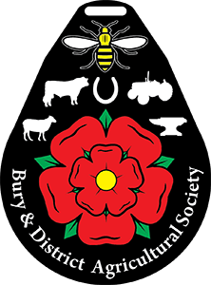

HEAVY HORSE SCHEDULE
SATURDAY 28TH JUNE 2026
Showground: The Show Ground, Burrs Country Park, Woodhill Road, Bury BL8 1DA
www.buryagricultural.org.uk

This show is affiliated to: Shire Horse Society & Suffolk Punch Horse Society

Bury Agricultural Show Horse Section wishes to thank all sponsors and donors of prizes for their continued interest and support.

Please be aware there will be a lunchbreak, please see the schedule for when this will be.

Heavy Horse Section Secretary: Kate Brown
Mobile: 07516 047 819
Email: tinykatelou27@yahoo.co.uk

Bury Agricultural Show Equestrian Rules of Entry

❖ All prize money MUST be collected on day of the show or will be forfeit.
❖ Only Horseboxes and Cars towing trailers will be allowed into the horse parking area.
❖ Entries would be appreciated via Entrymaster. Entries close at Midnight, Sunday 21st June 2026. Late entries will be accepted if space allows. If you wish to enter on the day, this will include a supplement fee of £5.00 per class if you have already entered the same horse/pony or are sharing a vehicle already planned to be at the show.
❖ Competitor first aid must be paid for when submitting entries. (£2)
❖Each exhibitor will receive 2 tickets; additional tickets can be booked in advance.
❖ The organisers accept no responsibility for loss or damage, injury or accident to spectators, exhibitors, riders or their property as a result of attending this show. Please take appropriate care to prevent such accident or loss to yourselves and others. All competitors must hold suitable Public Liability insurance and a valid equine passport.
❖ Equine Influenza – all animals to have received an annual vaccination within 12 months of the show or if have had to start a new course proof of the 1st & 2nd vaccinations will be required.
❖ Riders must wear up to date hard hats secured with a chin strap.
❖ No persons other than the exhibitor, handler, judges and stewards are allowed into the rings.
❖ Age for horse/pony and rider as of 1st January 2026
❖ All stallions and colts should be suitably bitted and handled by persons 16 yrs. and over.
❖ The organiser’s reserve the right to divide, amalgamate or cancel any classes should entries warrant it.
❖ The Judge’s decision is final. Any formal objections should be made in writing (official form available from the Secretary’s marquee) and handed to the Secretary, accompanied by a deposit of £20, before leaving the show. The deposit will be refunded if the objection is upheld. You will be notified of the decision by post.
❖ No horse/pony to be left unattended tied outside a horsebox/trailer.
❖ No mucking out on the showground.
❖ Mistreatment of any animal on the Showground will not be tolerated. The organisers reserve the right to ask anyone to leave.
❖ By entering any class, you agree to abide by the rules above. The above rules are additional to the general show rules.

DUE TO HEALTH AND SAFETY STRICTLY NO VEHICLE MOVEMENT BEFORE 4PM

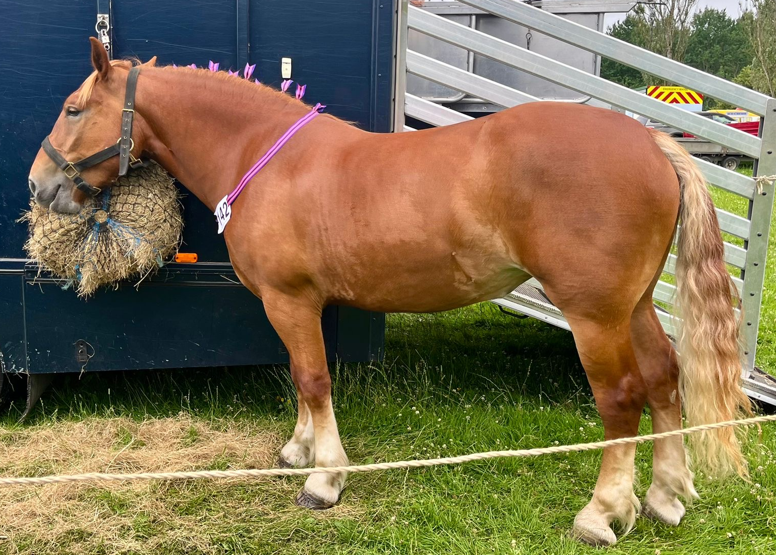

SUFFOLK HORSE SECTION

Classes will commence at 10.00 am Judge: TBC

Entry Fee per class: £10.00
Prize Money: 1st Prize £20.00, 2nd Prize £15.00, 3rd Prize £10.00
Rosettes to 5th Place

“This show is affiliated to the Suffolk Horse Society (SHS) championship points for annually awarded trophies and for the Supreme Suffolk Horse Championship.
All entries for In Hand classes must be registered in or eligible for registration in the Pedigree Section of the UK Suffolk Stud book. All entries must state their SHS registration number and full pedigree name including prefix or affix.

All foals must be eligible for registration in the Pedigree Section of the UK Suffolk Stud Book. Both the sire and the dam must be registered and entered in the pedigree section of the UK Suffolk Stud Book. All stallions must be registered in the Pedigree Section of the UK Suffolk Stud book. All entries must state their SHS registration number, stallion licence number and full pedigree name including prefix or affix. Discretionary entry to a stallion class may be allowed in cases where a licence is pending but not yet issued. All owners entering their horses must be members of the Suffolk Horse Society”.

Special Class – Best Turned-out Suffolk Horse, open to all Suffolk Horses.

Class 1 -Yearling – Colt, Filly or Gelding
Class 2 - 2 and 3 year old Mare or Gelding
*Highest place of each age will receive a special rosette*.

Class 3 - 4 years old and over Mare – open to mares and mares with foals at foot
*Special rosette for best foal in show*

Class 4 - Geldings 4 years old and over
Class 5 – Stallion 2 years old and over
Class 6 – Veteran (15 years and over) – Mare or Gelding
Class 7 - In hand Working Harness – The horse should be dressed in no more harness than it would be if it were to work Ridden

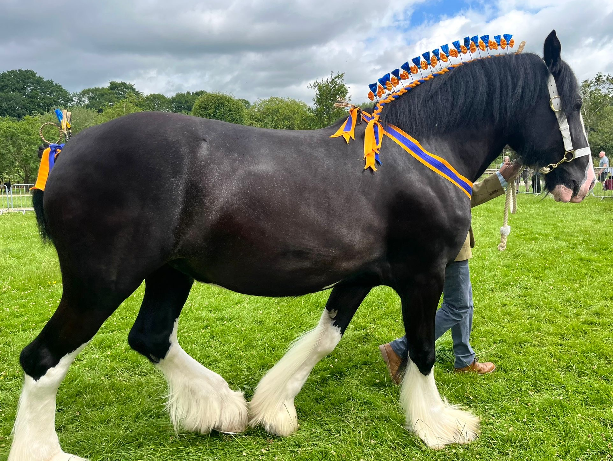

SHIRE HORSE SECTION

Classes will commence 13.00pm Judge: TBC

Entry Fee per class: £10.00
Prize Money: 1st Prize £20.00, 2nd Prize £15.00, 3rd Prize £10.00
Rosettes to 5th Place

Class 8 – Yearling – Colt, Filly or Gelding

Class 9 – 2 and 3 year old Mare or Gelding
*Highest placed of each age will receive a special rosette*

Class 10 – Shire Horse Broodmare (foaling 2026)
This class is a qualifier for the Shire Horse Society’s Summer Brood Mare Supreme Championship with the final being held at the 2026 National Summer Show at Rockingham Castle on 27th August 2026, where the ultimate winner will receive prize money of £1,000 with £500 to second, £250 to 3rd, £100 to 4th, £50 to 5th and then £25 from 6th-10th.

Class 11 – Best Foal

Class 12 – Gelding or Mare 4 years and over

Class 13 – Stallion 2 years and over

Class 14 – Veteran (15 years and over)

ANY OTHER BREED SECTION

Classes will follow on from Shires Judge: Steve Ledsham

Entry Fee per class: £10.00
Prize Money: 1st Prize £20.00, 2nd Prize £15.00, 3rd Prize £10.00
Rosettes to 5th Place

Class 15 – Open in hand (Pure or Part bred)
*Excluding Suffolk punch or Shires*

Class 16 – Young Handler (Age 10 – 18 years)
*Open to ANY Heavy Horse Breed*

*CHAMPIONSHIP*
1st and 2nd Place from Classes 1 – 15
Judging to take place in the main ring at: 3.30pm
Reserve Champion and Overall, Champion of both Suffolks and Shires will be awarded in the main ring

